Lab #8 – Matt Cunningham
Digital Electronics
Combinational Logic Circuit – Comparator Circuit

Objectives:
- To design a functional comparator circuit that will compare 2-bit numbers. The numbers will be represented by A1, A0, B1 and B0. There will be two outputs, represented by GE and LT. GE will be high when a 2-bit A value is than or equal to a 2-bit B value. LT will be high when a 2-bit A value is less than a 2-bit B value.
Equipment Used:
- Quartus 18.1 Software with ModelSim
- DE10 board
Procedure:
- Produce a truth table for the inputs A1, A0, B1, B0 and outputs GE and LT. GE will be high only when the 2-bit A value is greater than or equal to the 2-bit B value. LT will be high when the 2-bit A value is less than the 2-bit B value.
- Design two K-maps based on the truth table. One for the GE output, and one for the LT output.
- In each K-map, group the common terms
- Using the grouped K-maps, create reduced expressions for both GE and LT
- With the reduce expressions, build the circuit in Quartus
- Compile the circuit
- Run a simulation of the circuit using ModelSim
- Use pin programmer to assign pins to the DE10 board
- Connect and program the DE10
- Test results on DE10 by putting the switches in all possible orientations from the reduced expression and confirming that the results are correct.
- Screenshot all major steps of the procedure (Truth table, K-maps, Boolean expressions, circuit design, simulation) and add to report
- Take images of various confirmed states of logic on DE10 board and add to report
Results:
I showed my professor the functional logic on the DE10 board. Below are all steps I took to build the functional program:
Question 1:
Boolean Expression, Truth Table and K-map:
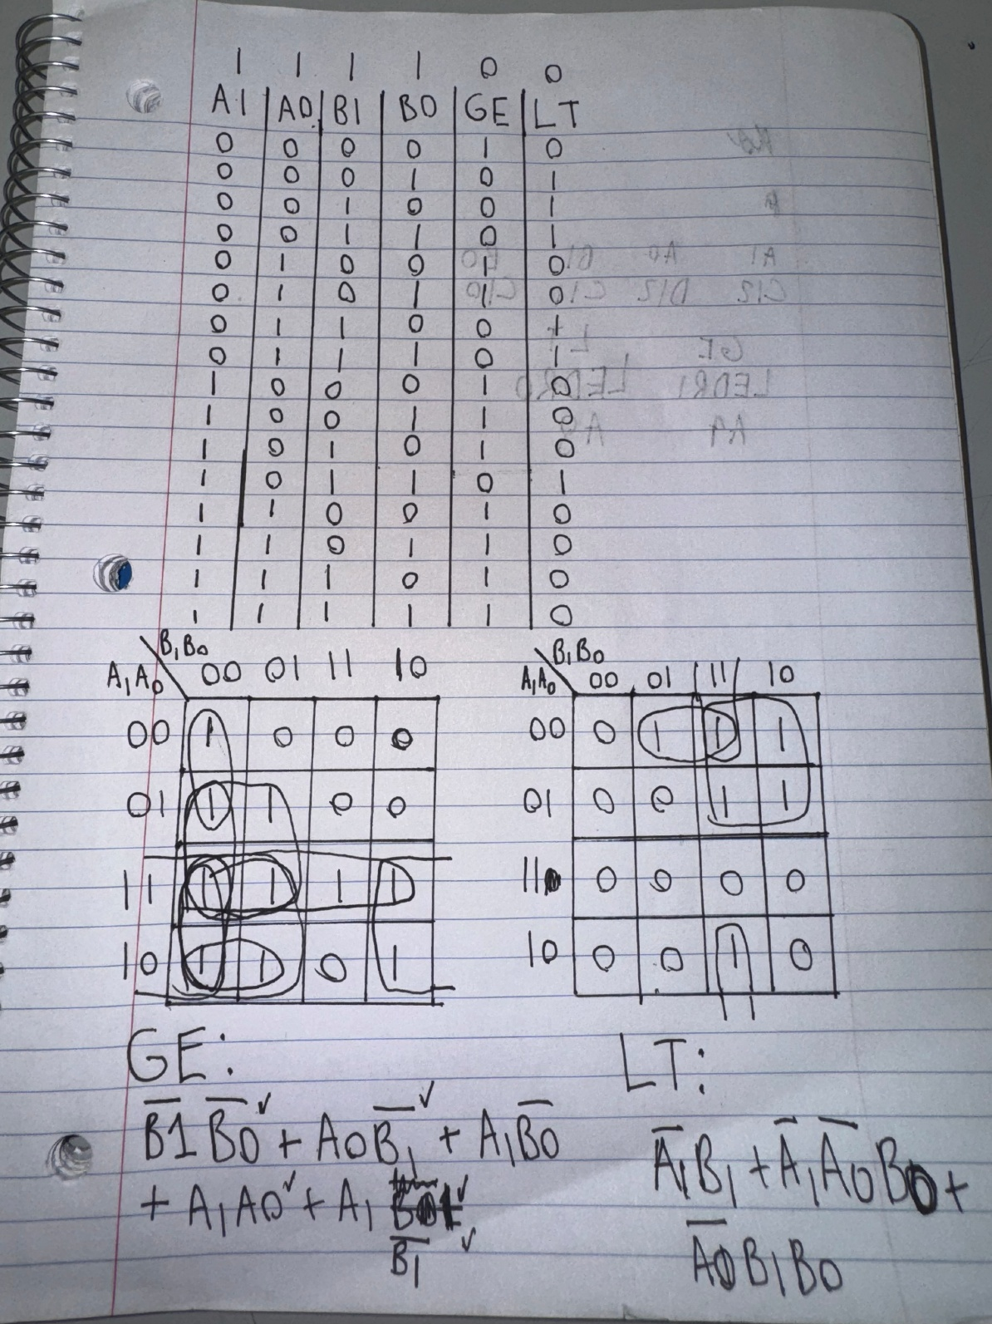

Circuit:
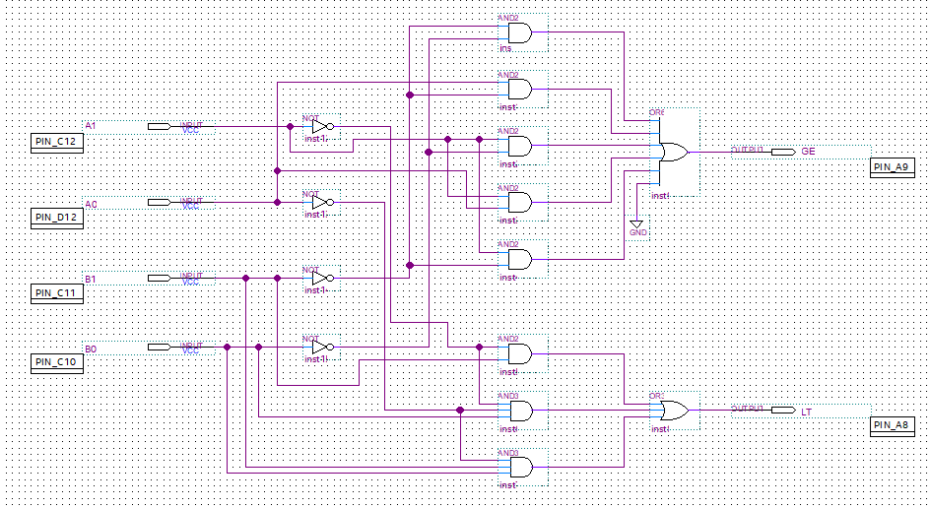
Timing Diagram:
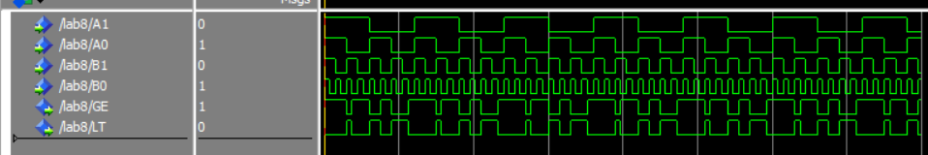
Images of working circuit on DE10 board:
GE HIGH
(B1’, B0’) (A0, B1’) (A1, B0’) (A1, A0) (A1, B1)
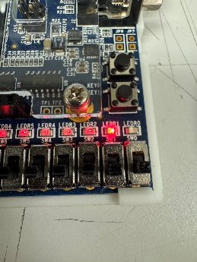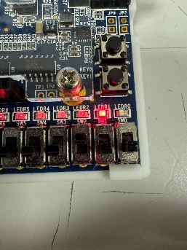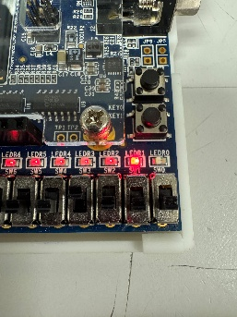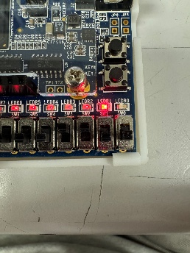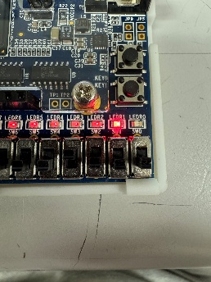

LT HIGH
(A1’, B1) (A1’, A0’, B1) (A0’, B1, B0)
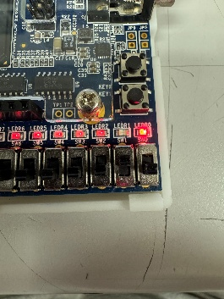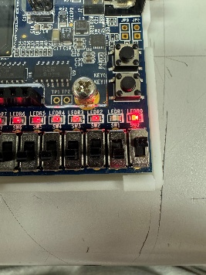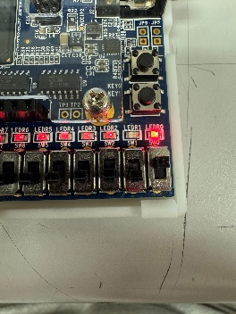

Conclusion:
The design of a comparator circuit comparing 2 different forms of 2-bit numbers has been successfully completed. Starting from a truth table, we were able to utilize K-maps to reduce the terms into a much smaller logical circuit, that achieved the same result.

